Part IV

Part IV

Since the 21st century, countries in the world have experienced rapid population and economic development. The total world population has grown from 7 billion to 8 billion. On this basis, with the continuous development of technology and industry, the per capita resource consumption is also increasing, which has brought a great burden to the earth's environment and resources.

In order to make precise arrangements for services, we studied the GDP energy consumption of countries at different development levels, divided the country into three types according to its per capita GDP, and gave different solutions.

We selected the data of representative countries such as Tanzania, Nigeria, Indonesia, China, Japan and Switzerland from 1980 to 2018, and used energy consumption per GDP to reflect their energy consumption efficiency as the abscissa; use GDP per capita to reflect their economic development Horizontal, as the ordinate.The relationship between them can be found by fitting:

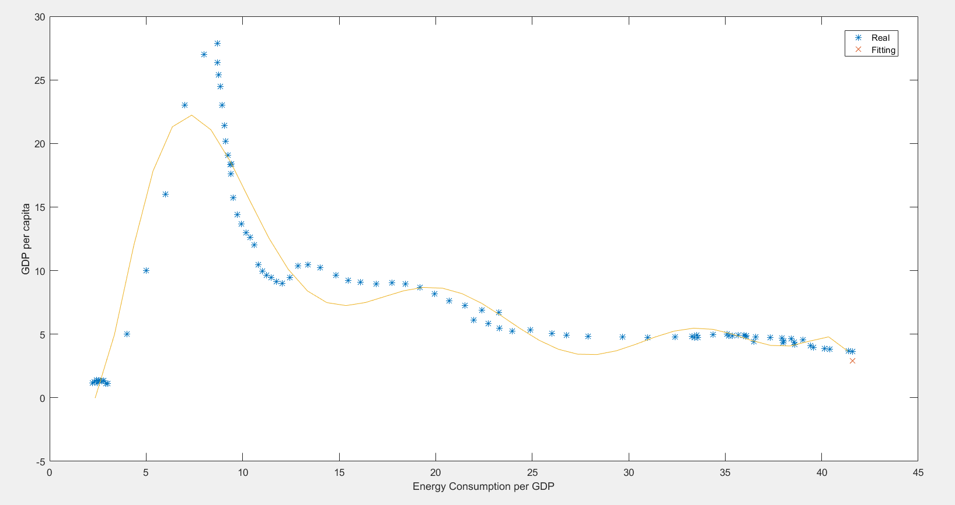

**Countries in the Early Stage of Industrialization**

The first type of country is in the early stage of industrialization, characterized by a high growth rate of per capita GDP and a high growth rate of per capita resource consumption. Representative countries are Tanzania and Egypt. For this kind of national economists and environmentalists, they have given accurate answers. In order to avoid falling into the Malthusian trap, on the one hand, it should be recommended that the country adopt a prenatal and postnatal care policy to cultivate more high-quality populations. It is not simply increasing the fertility rate, it is the heavy energy and environmental burden brought about by population expansion; on the other hand, the country should be provided with technical support and policy guidance to quickly transition from the early stage of industrialization to the late stage of industrialization, and give full play to the local characteristics of the industry Advantages instead of blindly emphasizing high output.

In the past few years, the world has provided developing countries with more and more funds to advance this agenda.

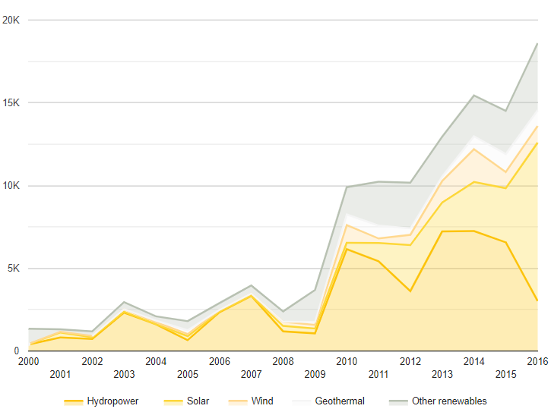

(figure: International financial commitments from official sources to developing countries in support of clean and renewable energy, 2000–2016 (billions of dollars, constant 2016 prices))

**Countries in the Middle of Industrialization**

The second type of country is in the middle of industrialization. It is characterized by a dense population, relatively developed local industries and a relatively complete industrial system. Representative countries are China and Indonesia. For this type of country, our recommendations are mainly to strengthen the adjustment of the industrial structure and energy structure. take China as an example. China has a large number of coal mines. In the past few decades, China's industry has formed an extremely high dependence on coal mines, which has also caused serious environmental problems. In order to avoid the deterioration of environmental and energy problems, the industrial structure should be promoted to shift from a resource-intensive industrial structure dominated by raw material industries and low value-added industries to a knowledge-intensive industry dominated by high value-added industries. Structural shift: In terms of energy structure, we should give priority to renewable energy and clean energy, such as nuclear energy, wind energy, and tidal energy. Take the following figure as an example. If we keep the growth rate of China's energy consumption unchanged and use our improved methods to adjust the energy structure, the total carbon emissions can be greatly reduced.

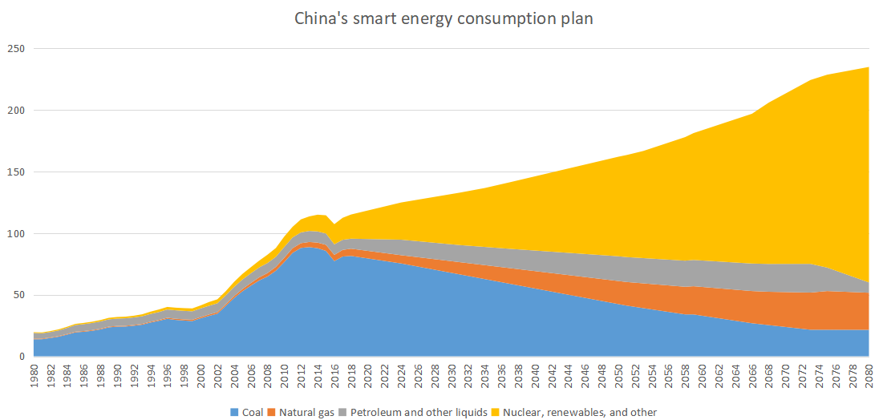

**Developed Countries**

The third type of countries are mostly developed countries, with high per capita GDP and low energy consumption per capita, but the per capita energy consumption is very high. Typical countries are Sweden and the United States. For this type of country, our recommendations are mainly to reduce per capita energy consumption and carbon emissions. Take France as an example. France has maintained a steady growth rate of energy consumption since the 1980s. In addition, France attaches great importance to nuclear energy, and France has greatly reduced carbon emissions while increasing its total energy consumption.

